CNN for classifying Sinal+Noise and Noise

# Objective

To come up with a CNN classifier architecture, which occupies minimum memory,is computationally efficient and has high classification accuracy.

# References

* <http://cs231n.github.io/convolutional-networks/>
* <http://www.vlfeat.org/matconvnet/>
* Deep Neural Network acoustic models for ASR by Abdel-Rahman Mohamed (Dissertation)
* <http://www.robots.ox.ac.uk/~vgg/practicals/cnn/#part1-1>
* Spoken language identification with deep convolution networks

# Network architecture

I took the network architecture comparising of total 17 layers. It has 7 convolutional layers and Softmax layer for classification. Activation function is always ReLU.. The last layer is trained using a softmax loss.

Filter depth sizes have been increased to 50 and then decreased again to 2.

The figure below shows the archiechture

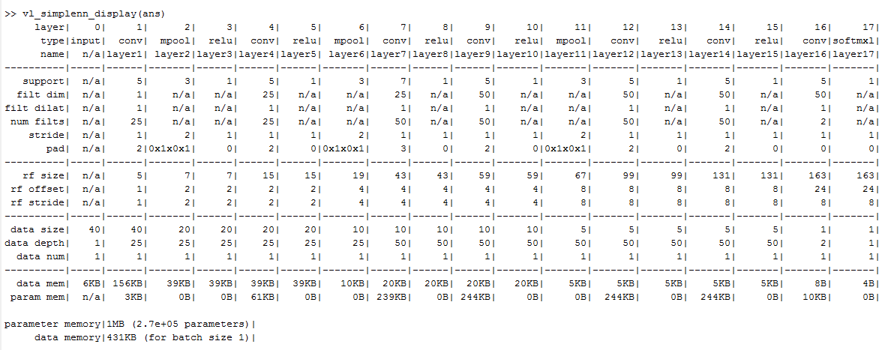

# Analysis

We have x no of parameters that we can change and analyze their effect on the CNN output. They are

1. Learning rate: I used large learning rate for the initial epochs to reach the minimum point of the gradient faster and gradually the learning rate is decreased by factor of 10. I tried using different values of learning rate i.e. but he effect on the accuracy was negligible. Decreasing it just increased the time required to compute each epoch. Therefore I have used small learning rate for the last 5 epochs for precision.
2. No of layers : The effect of number of layers :Among the different type of layers I used the number of ‘Conv’ layer mattered the most. The addition of 2 convolution layer increased the accuracy by almost 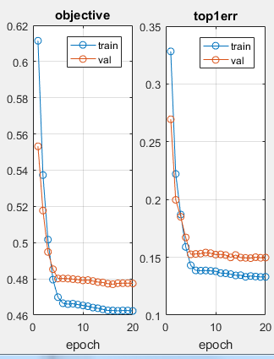 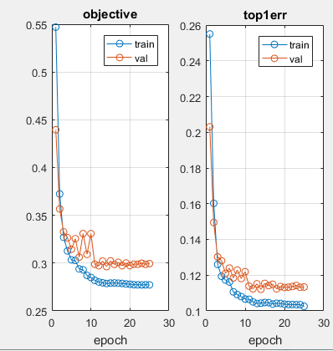

rELU

ReLu Layer :It was found to accelerate the convergence gradient descent

filter size: Increasing the number of filter size did increase the accuracy and also the increase in the size of filter increases the receptive field.

I have choosen 5*5 filter size as the majority one but apart from that I have also used 7*7 filter also.

1. filterdepth:I have tried different values for the ilter depth but
2. batch size: